Db927283 VAN HOU HEI Assignment 8 MATH2009

Complete Source code can be refer to

<https://github.com/MichaelVanHouHei/R_Lectures/blob/main/assigment8.R>

the code should be completely fine, denote that I didn’t use “install.package” since it shown the error “not support version on R” , so that I use remote install from github

if missing alr3 package please remove the “comment” at line 2

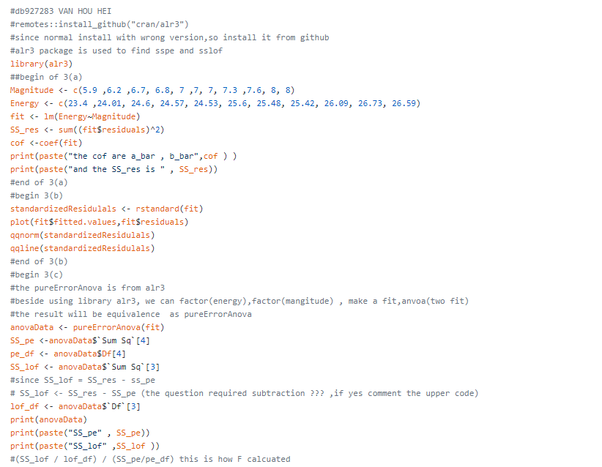



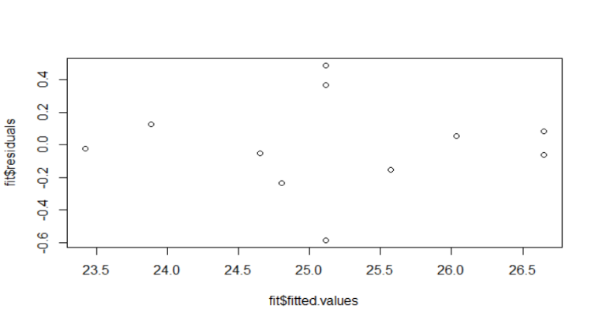

Fig1

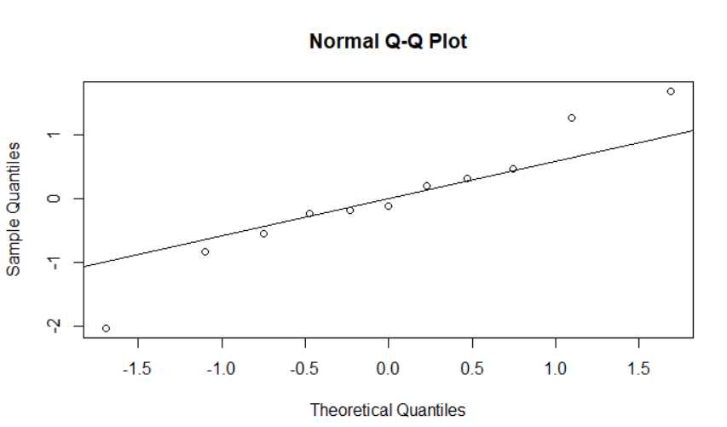

Fig2

Question 3 (all result)

3(a) 

3(b) please refer to figure 1,2

3©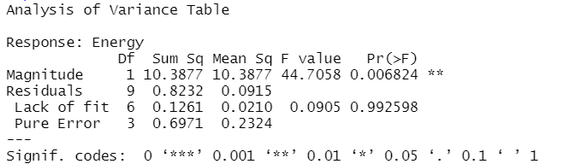

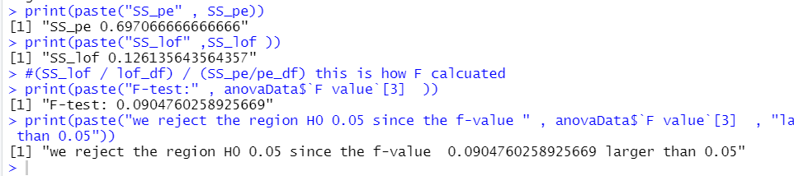

Question 1 $$\begin{aligned}\sum_{i=1}^{k}{ }\sum_{i=1}^{n_{i}}{ }{\left(Y_{ij}-{\hat{Y}}_{i}\right)}^{2}&=\sum_{i=1}^{k}{ }\sum_{i=1}^{n_{i}}{ }{\left[\left(Y_{ij}-{\overline{Y}}_{i}\right)+\left({\overline{Y}}_{i}-{\hat{Y}}_{i}\right)\right]}^{2} \\ &=\sum_{i=1}^{k}{ }\sum_{j=1}^{n_{i}}{ }\left[{\left(Y_{ij}-{\overline{Y}}_{i}\right)}^{2}+2\left(Y_{ij}-{\overline{Y}}_{i}\right)\left({\overline{Y}}_{i}-{\hat{Y}}_{i}\right)+{\left({\overline{Y}}_{i}-{\hat{Y}}_{i}\right)}^{2}\right] \\ &\left.=\sum_{i=1}^{k}{ }\sum_{j=1}^{n_{i}}{ }{\left(Y_{ij}-{\overline{Y}}_{i}\right)}^{2}+2\sum_{i=1=1}^{k}{ }\sum_{i}{ }\left(Y_{ij}-{\overline{Y}}_{i}\right)\left({\overline{y}}_{i}-{\hat{Y}}_{i}\right)+\sum_{i=1=1}^{k_{i}}{ }{\left({\overline{Y}}_{i}-{\hat{Y}}_{i}\right)}^{2}\right\rangle \\ &=\sum_{i=1}^{k}{ }\sum_{i=1}^{n_{i}}{ }{\left(Y_{ij}-{\overline{y}}_{i}\right)}^{2}+\sum_{i=1}^{k}{ }n_{i}{\left({\overline{Y}}_{i}-{\hat{y}}_{i}\right)}^{2}\end{aligned}$$

Question 2

$$\begin{aligned}&\sum_{i=1}^{k}{ }\sum_{j=1}^{n_{i}}{ }\left\{\left(Y_{ij}-{\hat{Y}}_{ij}\left(i\right)\right)\left({\hat{Y}}_{ij}\left(i\right)-{\hat{Y}}_{ij}\right)\right\} \\ =&\sum_{i=1}^{k}{ }\sum_{j=1}^{n_{i}}{ }\left\{e_{ij}\left({\hat{a}}_{i}+{\hat{b}}_{i}x_{ij}-\hat{a}-\hat{b}x_{ij}\right)\right\} \\ =&\sum_{i=1}^{k}{ }\left\{\sum_{j=1}^{n_{i}}{ }\left({\hat{a}}_{i}-\hat{a}\right)e_{ij}+\left({\hat{b}}_{i}-\hat{b}\right)e_{ij}X_{ij}\right\} \\ =&\sum_{i=1}^{k}{ }\left\{\left({\hat{a}}_{i}-\hat{a}\right)\sum_{j=1}^{n_{i}}{ }e_{ij}+\left({\hat{b}}_{i}-\hat{b}\right)\sum_{j=1}^{n_{i}}{ }e_{ij}x_{ij}\right\} \\ =&0\end{aligned}$$

$$\sum_{i=1}^{k}{ }\sum_{j=1}^{n_{i}}{ }{\left[\left(Y_{ij}-{\hat{Y}}_{ij}(i)\right)+\left({\hat{Y}}_{ij}(i)-{\hat{Y}}_{ij}\right)\right]}^{2}$$

$$\begin{aligned}&=\sum_{i=1}^{k}{ }\sum_{j=1}^{n_{i}}{ }{\left(Y_{ij}-{\hat{Y}}_{ij}(i)\right)}^{2}+2\sum_{i=1}^{k_{i}}{ }\sum_{j=1}^{n_{i}}{ }\left(Y_{ij}-{\hat{Y}}_{ij}(i)\right)\left({\hat{Y}}_{ij}(i)-{\hat{Y}}_{ij}\right)+\sum_{i=1}^{k}{ }\sum_{i=1}^{n_{i}}{ }{\left({\hat{Y}}_{ij}(i)-{\hat{Y}}_{ij}\right)}^{2} \\ &=\sum_{i=1}^{k}{ }\sum_{j=1}^{n_{i}}{ }{\left(Y_{ij}-{\hat{Y}}_{ij}(i)\right)}^{2}+\sum_{i=1}^{k}{ }\sum_{j=1}^{n_{i}}{ }{\left({\hat{Y}}_{ij}(i)-{\hat{Y}}_{ij}\right)}^{2}\end{aligned}$$